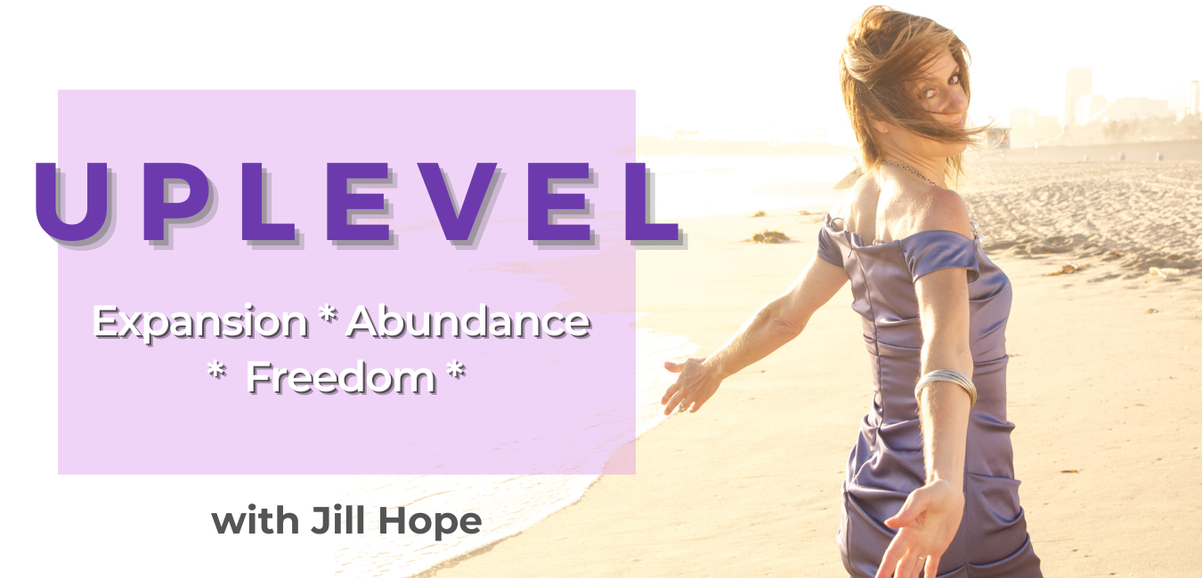
UPLEVEL Program
Guidebook

Training 1: Orientation and Program Introduction

Welcome to UPLEVEL: Skyrocket Your Business, Bank Account, and Life This Year and Live Life in Expansion, Abundance, and Freedom!

What does it mean to uplevel? UPLEVEL is all about stepping into the life you want to live NOW.

It means running the business you want, living and working in the environment you want, having the quality of relationships you want, having the exact amount of money you want, having all of the fun experiences you want, having the spiritual growth you want, even having the body you want…and shifting into the experience of having ALL of this in your life NOW.

How the Program Works
8 Trainings. Most of the trainings will be around 45-60 minutes, with the exception of Training #1 which will be closer to 90 minutes.
Workshop Style. I will provide a little bit of content to set the tone of the training, and then the bulk of it will be having you do some reflection on a key area of your life. There are 7 key areas in total that we’ll be covering in this program.
Monthly Group Coaching Call. Through the group coaching calls, you will receive accountability and support as you integrate your takeaways from training. There will be specific actions you’ll be implementing each month so following the actions and participating in the coaching calls will be crucial to your success.

Training #1: Orientation / Introduction - Our first training will lay out how this program is designed and then we’ll cover some key foundational pieces that will support everything we are doing in this program. This training will essentially set the mindset and the focus for the uplevel.
Trainings #2 - #8: The remaining 7 trainings will cover 7 key areas and will set the framework for physical change. The 7 key areas are:
Environment
Relationships
Money
Body/Wellness
Business/Career
Fun
Spirituality
In each training workshop, we’ll talk about the area of focus, how it impacts your ability to live the life you want to live, and then I’ll give you some guidance, reflection time, and action steps you can take to uplevel that particular area.
You will have integration support and accountability through the coaching calls to ensure that you are able to be successful in creating important and powerful shifts in each area.

The Power of a Vision
Vision is so important and here’s why: We create meaning in the present based on our desires for our future.
It’s also important to keep in mind that your mindset affects your vision. You can keep yourself stuck in a loop and not really expanding and growing as you’d like if you don’t check your mindset.
So when you think about what you want and you think about your vision, here are two important questions to consider:
- What mindset are you operating under as you create your vision?
- What mindset is the version of YOU who has what you want operating under when she creates a vision?

Your Mindset Affects Your Vision
Two key mindsets for the purposes of this discussion:
- Middle-Class Mindset: Survival mode
- Entrepreneurial / Millionaire Mindset: Expansion and leadership mode

Some Key Beliefs/Focus of The Middle-Class Mindset:
- You are looking to get out of survival mode
- You see problems as something to be avoided and that mean something is wrong
- You clamp down when money gets tight

- Amount of money you make is contingent upon how much and how hard you work
- You receive money based on work
- You believe you are stuck in the situation you were born into
- Your value is based on how much money you spend and make
- You believe more in your circumstances and situation than in your vision and desires
- You set small, short-term goals
- You are rushed and always in a hurry to make things happen
- You are often in “fire-fighting mode”
- You have to feel “ready” before you take the next step
- You’re afraid to do the “wrong” thing

Question: Which of these beliefs are active in you?

Some Key Beliefs of The Entrepreneurial/Millionaire Mindset:
- You’ve mastered survival mode – so you’re no longer trying to get out of it
- You believe that opportunity is around you all the time
- You see problems are a door to the next opportunity
- You double-down on your vision and do MORE when things get tight
- You earn money through service
- You believe that you can create anything that you want
- You believe in your vision more than your circumstances or situation

- Amount of money you make is based on to what degree you serve and how many people you serve as well as on passive income strategies
- You don’t base your value system on how much money you spend and make
- You set longer term, bigger goals
- Things move more slowly
- You say yes and take the next step before you feel ready
- You know there are no mistakes, only lessons to be learned

Question: Which of these beliefs are active in you?

The Future You
As you think about living life at a new level, it’s important to think and do things differently, the way the Future Authentic Abundant You would think and act. In order to access the Future You and see the opportunities that will move you there, you must shift your mindset and upgrade your identity. This means you must be willing to risk your core identity to move forward.

How to Shift From Survival Mindset to Expansion Mindset
One of the ways you can shift from being in survival mode to being in expansion mode is to shift your focus by connecting to a bigger future that is further out. Then prioritize the important over the urgent.

You’ll want to give yourself the space to think beyond your current experience and start investing in your future self. Further out goals can help you do that. We’ll come back to that in a bit.

Activity: Expanded YOU Visualization
Journal Questions:
- Bring into view your future, expanded YOU.
- Notice what feelings are present within the expanded you? Write these feelings down now.

- Who is this bigger, expanded you? What kind of life do you see her living?

- What does the bigger, expanded you believe? Write these beliefs down now.

- From the perspective of your expanded YOU, what is the most important objective you could accomplish now, in your current state of awareness? What few areas does she want to prioritize now that will lead you to expanding into this future you?

Concept of the Self-Image and the Future Self (The Self-Image and Expansion Into Abundance)
A few ideas about Your Future Self…

- Your future self is very different from who you are today. You can know this because if you think about who you were 20 years ago or 30 years ago, you can probably see a lot of differences between who you were then and who you are now, right?
A common mistake people make is thinking that their future self is basically the same as they are today.
- The current you and the future you care about different things, see things differently, and act differently. You hold different mindsets. We talked a little bit about the mindsets.

- Your future self and the life she lives is like a garden. If you’re not intentional about what you are putting into the garden now, it will be overrun with weeds and randomness. This is the result of having no goals, or having cloudy goals, or having too many competing goals and priorities.

If you want to live into your future self, realize that she is different than you are now. This means you need to start creating her now…investing in her now so she can bear new fruit. Just like planting and nourishing seeds in a garden that will bear fruit, you need to plant the seeds and nourish your future self if you wish to receive the fruits you desire.
The key is to decide: What do you want your future self to be?

The Vision I Have for My Future Self:

This course is about practicing at investing in your future self, meaning what you do now affects your future self. So, it’s about making choices and decisions now that will align with and develop you into your ideal future self.

Contextual Purpose and the Future Self
Your Contextual Purpose Leads to Your Future Self.
What is a contextual purpose? This is something Viktor Frankl determined when he lived in a concentration camp in the 1930’s during the holocaust. Different from a life purpose, which many people ponder on for much of their lives, a contextual purpose is a purpose based on where you are at in a particular moment in your life.

It is a highly specific future goal that gives meaning and direction to your life right now. It is the next level that would be utterly amazing to achieve. It is the most important thing you can do right now, and it is rarely more than 5 or possibly 10 years out.
Your contextual purpose leads you on the path to your future self.
So you’ll want to get clear on your contextual purpose, and you can do so by considering 3 things.
- Connect with your long-term future self and ask “what is the most important objective I could accomplish now? What few areas do you want to prioritize based on what you want your future self to be? We did that during the visualization.
Notes

- Clarify your contextual purpose through your 3 major priorities. Ask “based on the most important objective I could accomplish now, what are my top 3 priorities? What 3 priorities would take my life to a totally different level?

My 3 Priorities based on my contextual purpose:

- Set big 12-month targets based on your 3 priorities

Creating Your 1, 5, and 10-year Goals
Keeping everything we’ve discussed thus far in mind, I invite you to go back over the goals and dreams you have for this year, and update them based on what I’ve shared here today. In addition, I invite you to create your 5-year and 10-year goals. You’re expanding outwards a bit and seeing where you’d like to go and grow over time. With these longer-term goals, you’re aiming beyond what you think you are capable of and make it your goal.
5-Year goals should be prioritized before the urgent daily battles. When you’re focused on the small, urgent, and short-term, you’ll miss the golden opportunities all around you for the bigger goals.

Why? You perceive based on how you think and focus, and these things are conditioned. If you’re looking at circumstances only, you’ll see only things that match it. You get what you focus on.
We need to think beyond the circumstances and focus on our bigger, longer-term goals to see the opportunities that will help us get there. And we need to have bigger longer-term goals as a point of focus.

IMPORTANT NOTE
If you’re someone who doesn’t like to set goals or feels they are too confining and you like to live your life in flow, consider this: Goals create flow and give direction and bring energy to our lives!
When you are clear on what you want, you step into a flow that guides you right there. It feels intentional yet there is an ease and a sense of the miraculous in what shows up.
When you are foggy on what you want, you wallow around and see different opportunities but you lack clarity on which opportunities to take, which decisions to make, and you may or may not like where you end up.
If you are foggy on what you want, create a clear goal to create clarity in the particular area where you are foggy. That IS a goal!

HOMEWORK
- Activity #1: Who is Your Future Self

Directions: Write a paragraph / vision describing your Future Self based on the visualization and everything we’ve discussed thus far. Consider the following:
  - What does your future self believe? What does she think about? What is important to her? How does she dress? How does she

carry herself? What are her habits? What does she like? What is her perspective on things?

My Future Self Vision

- Activity #2: Create Your 1, 5, and 10-year Goals
Directions: Clarify your 1, 5, and 10 year goals based on the work we’ve already done here today. Keep in mind your contextual purpose and top 3 priorities.

My Contextual Purpose

My Top 3 Priorities

#1:
#2:
#3:

My 1-Year Goals

My 5-Year Goals

My 10-Year Goals

