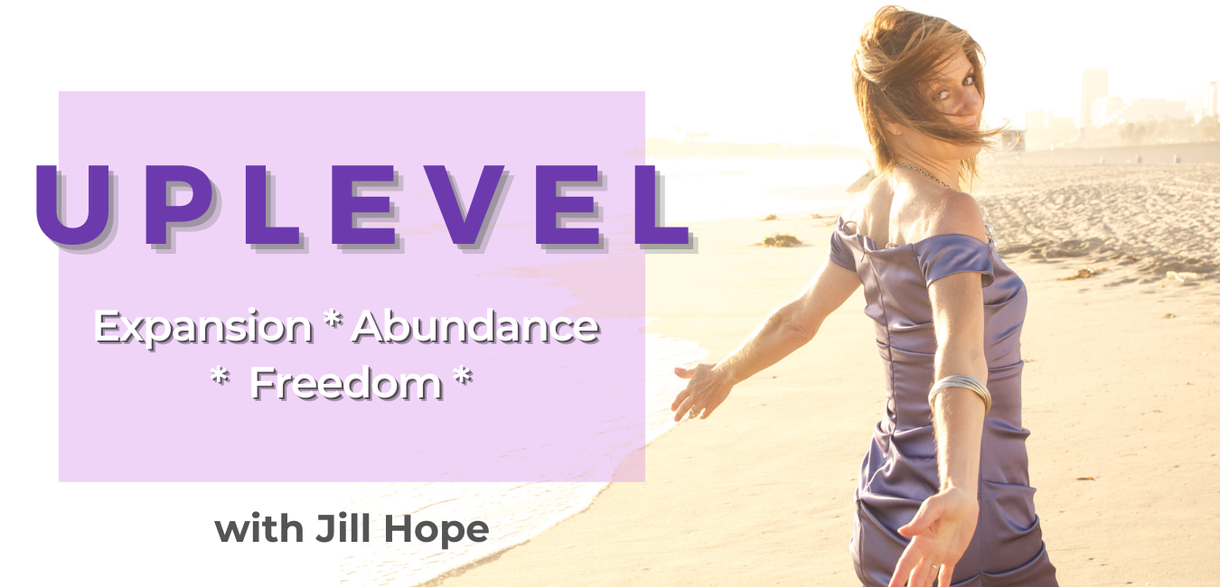
UPLEVEL Program
Guidebook

Training 2: Elevate Your Environment to Luxe 5-Star Status

Uplevel your space and watch as you elevate into the 5-star life you were born for.

Goal: Shape your environment to pull you in the direction of your future self.

In this training, you will learn:

Why your environment impacts your ability to create the financial and business success you want

How to determine what you need to shift in your environment to get in alignment with your future self so you can live your dream life now

- The key to stop settling and step into your upleveled environment now

The Impression of Increase

“The impression of increase takes place when you transform from being a needy person to a person of value.”
~David Neagle

When you come from need and desperation or lack in any way, you a send out a message that is NOT the impression of increase. This is a problem and here is why.

Everything in the universe is seeking increase. We seek that which allows us to grow.

If you come from a dysfunctional paradigm (where you feel needy or unworthy, for example), the increase you’re seeking will cause you to go in the wrong direction.

This is due to the operation of the divine principle, which is: More Life

The principle takes whatever you give it and grows it. And it responds to energy, not words. It is always moving things forward.

So if you have dysfunctional ideas in your mind, the “more life” principle will grow it.

As the dysfunction grows, you decline due to the more life principle.

The key is to recognize the rules you are playing by that are preventing you from making progress, and then change them. That is what you’ll be doing by examining the 7 areas in this program.

Elevate From Needing to Wanting to Knowing

Needing implies a deep state of lack in that you can’t be whole or happy until the need is filled.

Wanting is healthier than needing but is still a state of lack because it assumes you don’t have what you want.

Knowing is a higher level than wanting. Knowing is the acceptance that you already have what you want. Gratitude can take you there. When you know something is yours, you act differently than if you don’t know.

Knowing is an inner experience of a state of acceptance. Your vision is God’s promise.

“Whatever the mind can conceive and believe, it can achieve.”

~Napolean Hill

We attract what we ARE, so getting to a place of knowing and acceptance is crucial. Making the changes you’ll be making over the next 6 months in the 7 areas we will be discussing will help you to know and accept your future self, which will make it that much easier and faster to create what you want now.

Revisiting the Idea of Self-Image

What is a self-image or identity? It is the combination of values and beliefs and rules that you are most committed to.

Who you are today is not who you really are. And who you are today is not who you were 10 years ago. So why do we think that who we will be in 10 years will be the same as we are now? Why do we doubt that we can have a completely different, more amazing life in 10 years if we don’t exactly have that right now?

Dr Daniel Gilbert a Harvard psychologist who once gave a TED talk on the future self said that a core reason for this is because we have an easier time remembering but a more difficult time imagining. If we have a hard time imagining something we’d like to be in the future, we will often assume it’s not likely to happen, so we won’t believe we can create what we want.

Dr Carol Dweck called this same idea a fixed mindset, where we think everything we can ever be are fixed traits we were born with and we can never grow beyond it. A fixed mindset is being overly committed to your current self.

This lack of imagination and lack of belief in the possibility of our own growth potential creates a lack of confidence and the strong need to avoid failure.

“We attract what we are, not what we want”.

~James Allen from the book “As A Man Thinketh”

So the goal is to get to a state of fully accepting that what you want is already yours. This requires changing your current self-image/identity and assuming the image of your Future Self who already has what you want.

We need to see our current self and future self as different people. If you can do this, you can free your imagination to believe you CAN create something greater.

Behaviors follow beliefs. When you know different, you do different.

So, in this course, you’re going to baby step your way to being your Future Self now.

And now I want to share a big takeaway and something that helped me see instantaneously something big that I need to release:

DON’T STICK WITH SOMETHING JUST BECAUSE YOUR FORMER SELF CHOSE IT. QUIT EVERYTHING THAT ISN’T LIVING AS YOUR FUTURE SELF

Your Environment And Success

What do I mean when I talk about your environment? Your physical surroundings, how you move through your space, how you manage and maintain your space, as well as other environments you put yourself in.

You will likely only get yourself so far from your current environment if it remains unchanged. This is one of the reasons why a person born in the ghetto has such a hard time changing their life. Their environment plays a big role in keeping them right where they are.

The good news is that little changes and shifts can make a HUGE difference.

Meaning, you don’t have to move into a new home (or move into a new pot) to make an impact on your self-identity and help yourself expand. Even something simple like moving a piece of furniture to a more pleasing space, getting a new piece of art that inspires you, clearing out a closet that has unnecessary clutter, or repairing or replacing something that is chipped or worn can make a big difference in how you show up and move through your space.

Upleveling your environment is also about creating new standards from the perspective of your Future Self around the type of environment you want to exist within.

And then it is about implementing your new standards NOW.

And then finally, it’s about completely appreciating what you’re creating.

Again….

DON’T STICK WITH SOMETHING JUST BECAUSE YOUR FORMER SELF CHOSE IT. QUIT EVERYTHING THAT ISN’T LIVING AS YOUR FUTURE SELF

Remove everything that conflicts with the purpose and priorities you’ve created.

If you don’t create and control your environment, your environment will control you.

Become aware of the impact of your external environment on your internal goals so you can realign with your future self.

We are creatures of our expectations. Our environment subconsciously sets expectations around what is possible. We rise or lower ourselves based on our environment and the expectations it subconsciously places upon us.

Committing to Your Future Self

Ask yourself: Are you committed enough to your future self to uncommit to what you currently have?

To adopt a new set of beliefs and lifestyle, you must uncommit to current beliefs and lifestyle and lesser goals (where the path is often clear).

What is a lesser goal? Anything that is NOT taking you toward your future self.

Why do we choose lesser goals and NOT commit to what we truly want and therefore maintain what we currently have? Because we fear the repercussions, such as:

What if I make a mistake?

What if it is bad for my family or they are unhappy with my choice?

What if I lose the love of people I care about?

What if I lose friends?

What if I have regrets?

What if its not as great as I think it will be?

What if…..?

What are YOUR “what if’s”?

“Lesser goals are like weeds in the garden of your life. When you engage in lesser goals, you’ve planted a weed in your garden.”
~Ben Hardy in “Become Your Future Self Now”

Instead, he says “you want to optimize your garden for your future self”.

In other words, you want to plant seeds that make the garden of your future self flourish.

How do you commit to your future self? When you commit 100% to your purpose, you are committing to your future self.

- What things in your environment oppose or run contrary to your contextual purpose?
- What in your environment is outside your top 3 priorities?
- What are you still saying YES to that your Future Self would say NO to?
- What are you continuing to commit to that is taking you away from where you want to go?

ACTIVITY: Aligning Your Environment With Your Future Self

Connect with your Future Self. What does she want? Does your environment support that? Do you spend the majority of your time in a space that reflects the YOU who is living the life or having the thing or doing the thing that ultimately you desire to be, do, or have?

Ask the 7 Questions:
- What in your environment is in harmony with your future self?

- What needs to shift?

- What needs to be eliminated?

- What needs to be added?

- What boundaries do I need to set (or uphold)?

- What new standards am I choosing for myself?

- What specific action steps am I committing to with regard to my environment this month that when I look at them, will pull me in the direction of my future self?

My thoughts about my environment:

HOMEWORK

Activity #1: Determine what you need to shift in your environment to make a difference in your bottom line and elevate you to the 5-star life you were born for. Walk around your home into the different spaces and ask this question: Is this something my Future Self would choose?

Document your desired changes here:

Activity #2: Make a plan to change 1-3 things this month that you discovered. Share in our next coaching call.

The 1-3 changes I am making in my environment this month are:

