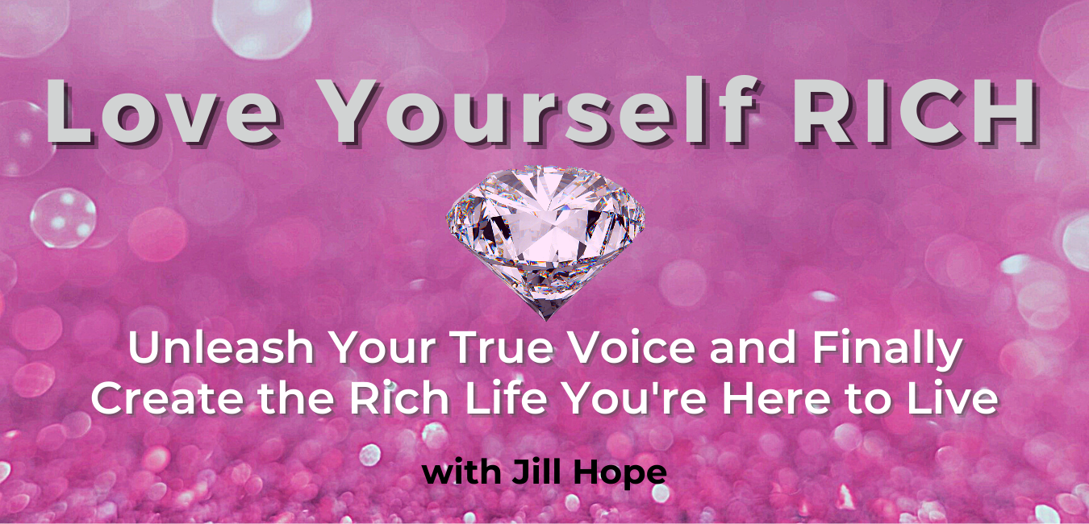
Love Yourself RICH

Unleash Your True Voice and Finally Create the Rich Life You’re Here to Live

With Jill Hope

The Voice of Self-Acceptance
Sessions 8 and 9

The Voice of Self-Acceptance
Training 8: Who Are You?
As we move into our third voice, it is important to pause and reflect on where you’ve come and where you are now.
In-Class Activity: Reflecting on my progress
Please pause and reflect on the following 4 questions. Write your responses down in the spaces below.
- What are the 3 most significant things you’ve discovered about yourself thus far?

- How will those 3 things help you to love yourself rich?

- What is the biggest 1-2 changes you’ve made as a result of what you’ve learned OR what are the biggest 1-2 changes you are willing and committed to making now?

- What questions or challenges do you still have about your voice of desire or voice of intuition?

What is Self-Acceptance?
First you connected with your Voice of Desire – knowing what you want, owning what you want, and giving yourself to permission to want what you want. This level of clarity and awareness about your desires is what gives you direction toward a particular result or outcome.
Then you connected with your Voice of Intuition – learning how to recognize this amazing resource that can guide you along your path to what you want.
Now, we are going to connect with your Voice of Self-Acceptance.
This is critical, because you can know what you want and decide to have it, you can start tuning in to your intuition, discovering how it speaks to you and consciously act on the guidance, and as you start to do those things, inevitably you’re going to bump up against things that will feel challenging to you and that will trigger old patterns of responding.
This is where driven, committed people will start replacing or substituting their voice of self-acceptance with the voices of self-betrayal as they move along their journey. Self-sabotaging voices such as:
Voice of Safety
Voice of Unworthiness
Voice of Procrastination
Voice of Perfectionism
Voice of Self-Doubt
Voice of Self-Criticism
Voice of Distraction
Voice of Shoulds and Shouldn’ts

This is where a lot of people stop. This is where a lot of dreams go to die.
However, when you reconnect with your voice of self-acceptance, she can help you to override any voices of self-betrayal that want to take over and sabotage your journey to living your dreams.
GOLDEN NUGGET: You don’t have to stop the voices of self-betrayal. You simply need to decide not to agree with them. You’ll want to become aware of when they come up and then make your voice of self-acceptance louder.
Notes

In-Class Activity: What is Self-Acceptance?
Take a few deep breaths and then imagine that you see a light in and around your heart – feel that light now – that is your light. Know that that light is always with you and you can tap into it and feel it at any time.
Notice that the light is connected with your inner child – the one who came in fully and completely accepting you just as you are. Notice that light connected to source – the one who knows you are infinitely worthy and perfect just as you are.
Now ask yourself: What is self-acceptance? What does self-acceptance mean to you? And what would it look like for you if you fully and completely accepted yourself, no matter what?
Be specific. Take a moment to write down your thoughts now.
Notes

Now, think about a recent situation that was challenging – write it down.
Notes

Next, imagine re-living that situation through the lens of self-acceptance. Ask yourself: “If I fully and completely accepted myself while I went through this situation – both during and afterward as I reflected on it – what would I have done differently in both my words and actions? How would it have been different in my experience?
Write down your thoughts now.
Notes

The Webster Dictionary Definition of Self-Acceptance
The act or state of accepting oneself : the act or state of understanding and recognizing one’s own abilities and limitations.
Notice that it said “and limitations”
It also said “recognize”. What does RECOGNIZE mean?
- To know or identify from past experience or knowledge.
- To perceive or show acceptance of the validity or reality of.
- To show awareness of; approve of or appreciate.

This quote by Linda Arnold takes it a step further:
“In each moment you’re either practicing self-acceptance—or you’re judging yourself.”— Linda Arnold
According to therapist Russell Grieger, “unconditional self-acceptance is an honest assessment and acceptance of your good and bad characteristics. It’s understanding that you are separate from your actions and your qualities. You accept that you have made mistakes and that you have flaws, but you do not let them define YOU.”
Two Key Takeaways:
>>Unconditional self-acceptance opens the door to loving yourself.
>>Every act of judgement against yourself is an act of self-betrayal.
Notes

Self-Esteem vs Self-Acceptance
Self-esteem refers to how you feel about yourself—whether you feel you are generally good, worthwhile, and valuable, while self-acceptance is simply acknowledging and accepting that You are who you are – the good, the bad, and the ugly.
When you accept yourself, you don’t make yourself wrong in terms of somehow being unworthy of good things or deserving of bad things.
That is not to say you don’t recognize where you could do better, but you don’t hate on yourself or make it mean you can’t have what you want.
Where self-esteem and self-acceptance are similar is that in both instances, they are about learning to separate what you do from who you are and understanding that you are not your actions or behaviors. Your actions and behaviors are simply a choice in a moment in time.
Notes

Acceptance vs Resistance
When I accept something, I am then much more powerful to do something about it (self-hypno).
Non-acceptance is resistance.
Accept that you’re too lazy, or tired, or that you lack commitment, etc. Simply acknowledge it and accept it – NO JUDGMENT!.
Once you do, you can then put plans in place to address it.
There is a very fine line between acceptance and resistance. Acceptance allows a release of resistance. When you release resistance, you are more open and in a greater state of allowing. The state of allowing is the state of flow. Resistance blocks flow.
GOLDEN NUGGET: Non-acceptance is resistance to what you want. It is a block on the path to creating what you desire.
Acceptance releases resistance so you can do what it takes to have what you want.

Leland Val Van De Wal spoke to this when he said: “The degree to which a person can grow is directly proportional to the amount of truth he can accept about himself without running away.”
Notes

Who Are You?
The greater YOU is a soul made of pure light and love.
But the YOU we are talking about for the purposes of this program – the you who wants to love yourself rich and live a life that you love on this earth is a little bit different, and that is the YOU you’ll want to accept, because it is your disowning or disavowing of those parts of you that creates resistance.
If you really could see yourself as pure light and love as you move through your everyday life we would not need this module.
But as enlightened and spiritual as you are, you are likely not seeing parts of yourself as the light and love that they are.
You are the things you like about yourself and the things you don’t like about yourself. You are the things you amplify and the things you hide. You are your preferences and desires. And so much more.

Homework: Who Are You?
You become what you think about. If you don’t fully accept all of YOU, then you are likely not being the TRUE YOU. When you are not the TRUE YOU, then you’ll attract into your life things that feel inauthentic and not true for you. If you don’t like what’s coming into your life, and you want your life to reflect your truth, then you must accept what is true for you, live in your truth, express your truth, BE your truth.
So, I’d like to invite you to think about who you are.
Self-Reflection: Who Am I?
What are your qualities (good and bad)? What is your essence? What are your habits? What do you notice about who you are – both on the level of being and the level of doing? What is true about you?
Make a list of everything you are. Include your roles, your qualities, your titles, your accomplishments, your perceived weaknesses, all of it. Take a few minutes and write what comes up for you in answer to the question “Who am I?”
I am:

Self-Reflection: Who Did They Say I Am?
PART 1: Although you were born as your true, authentic self, with your life purpose fully intact, the conditioning process kicks in which plays a BIG role in how your self-identity is formed.
Parents tell you who you are. And they show you who you are through their actions, their energy, their attitudes, and their expectations of you. Furthermore, situations produce feelings and conclusions within you that further layer onto your self-identity. These things can be good or not so good.
Then, when you get to school, the same process happens with your teachers, coaches, other important adults, and even your peers. Good things and not so good things.
All of this conditioning is layered upon your true authentic self, and seldom does your true identity match it.
So it is important to take a step back and see what you were told, what you deduced, and what you accepted as the truth about who you are. This is important so we can piece apart the real you from who the conditioning says is YOU so you can accept the TRUE YOU.
So, now I invite you to make a list of everything you were told you are – both desirable and not so desirable.
I’ve been told I am:

PART 2: Finally, review the list you just made above and circle the parts you feel are true and resonate with (whether you like them or not), and those that feel out of alignment or just not reflective of the true you. Compile a final list of who you are, pulling from both of the lists above, and write it out below.
My compiled list of who I am:

Training 9: Who Are You (Part 2)
How do you know if you aren’t accepting all of you? 6 Signs You Are Disconnected from Your Voice of Self-Acceptance.
Note: You may not have all of these and this may not be a complete list, but these are some of the most common signs.

- You feel like you don’t fit in and therefore have to change in some way in order to be liked.
TRUTH: Rather than change, you’re being called to become MORE of your true self. This feeling of not fitting in tells you that you aren’t being true to who you really are. Accepting yourself is accepting that not everyone will like you, and that fact in no way diminishes you nor does it suggest that you need to change.

- You settle for less than you desire and you justify it.
TRUTH: Part of accepting yourself is accepting what you want. When you settle for anything less than what you want you are not fully accepting and honoring yourself. God’s promise to you is full abundance in all things. You have a right to expect – even DEMAND it.

- You make yourself and your life smaller, not bigger. Some ways this can show up is being quiet, not using your voice, not speaking your opinion, not sharing your gifts, minimizing your accomplishments, not saying yes to your desires.

TRUTH: Life is about expansion. The ultimate universal truth is MORE LIFE to all, less to none. Accepting yourself means accepting that it is natural for you to desire and pursue expansion in all ways.

- You regularly have self-doubt. You often don’t trust yourself or your ideas. You have to get a lot of input from others before you can make a decision.
TRUTH: Listening to your intuition and accepting what you think about things and what you intuit is a part of knowing and accepting who you are.

- You don’t feel good enough. You regularly feel the need to prove yourself. You need to be acknowledged in order to feel good about what you do. This one is sneaky because it may not show up in all situations.
TRUTH: You were born good enough. You are worthy of all good things. You don’t have to prove yourself. All the abundance in the universe is yours simply because you exist. Self-acceptance means understanding and accepting that you deserve all good things even if you don’t feel worthy.

- You are a big bully – to yourself. You self-berate. You are hard on yourself.
TRUTH: You can’t grow without making mistakes. Being free from mistakes limits you. Worthiness doesn’t equal perfection. Self-acceptance means you can accept yourself despite making mistakes and you back that up with loving thoughts and words for yourself.

In-Class Activity: Who Does My Self-Talk Voice Say I Am?
You become what you think about yourself and what you say about yourself, whether you say it to yourself or others. Your self-talk affirms who you are.
So ask yourself: What do I typically say to myself in my self-talk? What do I say about myself when I refer to myself with others?
It is really important to become conscious of the words you use if you want to get down to the REAL you so you can accept the real you.
STEP 1: Make a list of what you say to yourself and what you say about yourself. Include both positive and negative statements that you regularly say to and about yourself.
This is what I say to myself:

STEP 2: Put a star by the ones you say the most and jot down the situations where you say these things to yourself.
These are the situations where I say this:

New Habits to Affirm Your Self-Acceptance
Affirmations can give you something to do with your brain when you are trying to break the cycle of old limiting patterns and instead, allow your Voice of Self-Acceptance to take a bigger role in moving you through challenges.
Affirmation #1: Adopted from EFT (Emotional Freedom Technique):
“Even though I am _______________, I completely love and accept myself.”
Ways I can show my love for myself even though I am ___________:

Affirmation #2:
“Even though I am _______________, I can still have/be/do ___________.”
Why is it true that I can still have ____________ if I am ___________?”

Ask the You Who Accepts Herself
In addition to affirmations, questions during challenges are also a powerful and important way to access different ways of thinking and behaving that can lead you to new and better results.
Question to Ask Yourself: If I completely loved and accepted myself in this situation, what would I think? What would I do?

A Final Thought
Most of the reasons why we stop ourselves from moving forward and toward what we want is that we live our lives based on false rules.
Through connecting with your voice of self-acceptance as well as all of your authentic voices, you are creating new rules, based in truth. These new rules support you in fully and completely accepting yourself just as you are.
Once you are aware fully of who you are and accept yourself, then you are freer to change anything you wish to change. You can create a new identity any time you choose too, but I’ve found that it is much easier if you first accept who you are now, fully and completely. It helps you create clarity on what you want to change and/or what you want to let go of.

Homework: Update/Complete Your “Who Am I” List
Go back to the previous 2 lists you made (who you are and who they said you were), and add anything new from your self-talk list. Create one complete list of everything you are willing to believe and accept as true about you – both the good and the bad.
My Updated “Who Am I” List – I Am:

