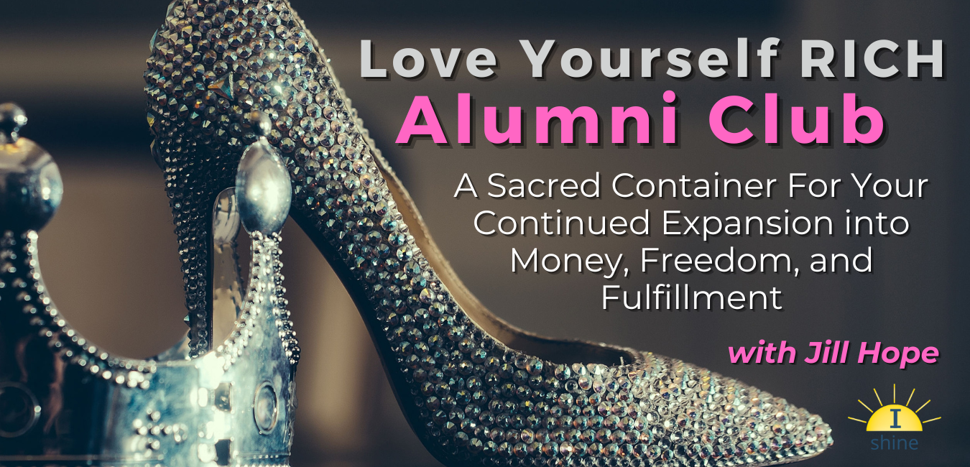
Love Yourself RICH

Alumni Club

With Jill Hope

Sept 2022

LYR Alumni Club Training Call #3: Embodying Your Sacred Money Archetypes
Your top 3 sacred money archetypes (SMA’s) are a powerful influence in your life, both the empowered sides and the shadow sides.
But up until now, we’ve focused almost solely on your #1 top archetype. In this month’s training, you’ll have the opportunity to tap into all 3 of your top SMA’s in order to more fully embrace and embody your archetypes and create an upgraded relationship with money.
We haven’t spent much time at all looking at your number 2 and number 3 archetypes, and it is important that we do so, because in some cases these archetypes can have an even bigger impact on you in certain situations.
Embodying your archetypes to create a new, upgraded relationship with money is about 3 things:
- Conscious awareness of how you behave with money, especially situationally since your behavior is often dictated by the situation you are in. Awareness grows through conscious intention, observation, and powerful questions.

- Creativity in determining new choices and opportunities so that you can start to make some new decisions in how you behave with money that will then bring you new results.

- Follow-through on the new decisions so that you can create new, more empowering money patterns. This is all about taking action!

Embodying a new way of being requires making new decisions and creating new patterns whenever you notice yourself slipping into old decisions or patterns. The more you catch yourself and take the new action, the more you let go of the old patterning and the more the new patterning can take hold.
The new patterning really starts to take hold as you start to experience different results. Those different results come from making different decisions. This is where your work really is when it comes to embodying your archetypes!

My Top 3 Sacred Money Archetypes:

#1 Archetype: ___________________________
#2 Archetype: ___________________________
#3 Archetype: ___________________________

Activity #1: Getting to Know Your #2 and #3 Sacred Money Archetypes
For your top 3 archetypes, read your Empowering Money Mindset, Your Sacred Money Contract, and your Sacred Strengths, Gifts, and Challenges.
Then complete the following instructions for each archetype, especially #2 and #3.
Archetype: ________________________________________
Step 1: How are you not living into your Empowering Money Mindset right now? Specifically, what you do you believe and how to you behave in relation to that Empowering Money Mindset? (these are your opportunities!)
My Thoughts:

Step 2: What would it look like, specifically, if you were actually living in alignment with your Sacred Money Contract? What would you be doing differently? What would you have to be believing to live in alignment with this contract?
My Thoughts:

Step 3: How am I not leaning into my Sacred Strengths? What could I do to lean into them more?
My Thoughts:

Step 4: How am I not leaning into my Gifts? What could I do to lean into them more?
My Thoughts:

Step 5: In what situations do my challenges arise? What initial steps can I take to overcome these challenges? In other words, what new decisions can I make?
My Thoughts:

ACTIVITY #2: Stepping Into Alignment with Your Top 3 Archetypes
The “Creating Sacred Money Alignment” questions on your Sacred Money Archetype cards will help you shine a light on the shadow side of your archetypes and will give you a more in depth look into these shadows. This happens by helping you see where you could be making different choices and as a result, how your shadows are holding you back.
This exercise helps you to practice the Conscious Awareness and Creativity steps in the process of embodying your archetypes. The final step, Follow-through is then required to put your new decisions into motion.
A few notes about these questions:
- They may not initially resonate with you. That is because they are cleverly designed to get you out of your comfort zone or habitual way of thinking. This is a good thing!

- They are designed to help you let go of operating from the shadow side of your SMA’s in a way that is challenging and inspiring and can open new doors of opportunity for you to create a life of freedom and financial success.

- They can help you break free of the “shoulds” and start living life in alignment with your true self

Step 1: Choose one question from each of your top 3 archetypes in the “Creating Sacred Money Alignment” section of your Sacred Money Archetype cards
Step 2: Journal on the question. Write your thoughts for each question below.
Step 3: Synthesize your new decision/s based on your journaled answer and write each new decision below.

Question for #1 Archetype: ________________________________________
_______________________________________________________________
My Answer:

New Decision/By When:

Question for #2 Archetype: ________________________________________
_______________________________________________________________
My Answer:

New Decision/By When:

Question for #3 Archetype: ________________________________________
_______________________________________________________________
My Answer:

New Decision/By When:

