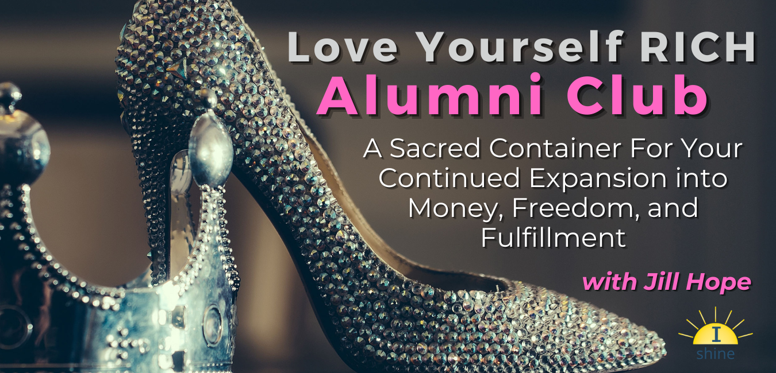
Love Yourself RICH

Alumni Club

With Jill Hope

October 2022

LYR Alumni Club Training Call #4: Aligning with Your Sacred Money Archetypes

If you’re living with any kind of money fear or fear of not getting a particular result you desire, especially if it’s related to money, you’re not living in alignment with your Voice of Money.
Some of the ways this fear can show up are…
- Money judgment
- Obsessiveness with money or saving
- Money guilt
- Fear around spending or giving
- Using money to cover up other fears or avoiding feelings
- Fear of looking at numbers
- Avoiding financial discipline
- Reckless, rebellious, or compulsive spending
- Doubting you can do what you really want to do
- Letting your core wounds of unworthy or unloveable zap your enthusiasm for what you’re working toward
- A deep-seated feeling that there’s never enough or that somehow you can’t share in the abundance of the universe

At the end of the day, money fear comes from limiting beliefs about yourself or about money.
Therefore, ultimately your limiting beliefs are what can keep you out of alignment with your Sacred Money Archetypes.
Your Voice of Money comes from the part of you that sees herself as abundant.
You can’t see yourself as abundant if at the same time you allow limiting thoughts about yourself or money to run the show.
These are 2 conflicting thoughts, and they can’t produce abundant results!
The reality is that until you DO something different, you won’t GET something different. Your doing is driven by your beliefs.
You’ll need to consciously create and set into motion a new plan of action if you wish to get a new result. Remember, YOU are the cause of your results. God/Universe/Divine is your source.
So, let’s get clear on specifically where you aren’t in alignment with your Sacred Money Archetypes and what beliefs are driving your lack of alignment. We’ll focus first on your strengths and then your gifts.

My #1 Sacred Money Archetype:

Archetype: ________________________________________

My #1 Sacred Money Archetype Strengths:

Strength: ___________________________
Strength: ___________________________
Strength: ___________________________
My #1 Sacred Money Archetype Gifts:

Gift: ___________________________
Gift: ___________________________
Gift: ___________________________

Activity #1: Where Are You Out of Alignment With Your Sacred Money Archetype Strengths?
Step 1: Think of specific situations and circumstances related to money or your business where you continue to struggle. List the situations or circumstances here:

Step 2: For each of the situations listed above, how do you specifically act or what decisions are you typically making?

Step 3: Look at your Sacred Strengths and compare them to the actions or decisions you are taking. Notice where your actions / decisions are in conflict with your Sacred Strengths. List all of the ways your decisions and actions do not line up with your Sacred Strengths.

Step 4: For each specific situation or circumstance you listed, ask yourself “What would I have to be believing to act in conflict with my sacred money archetype strengths in this situation?”
My current beliefs:

Step 5: Ask yourself “What could I choose to believe instead that would align my beliefs with what I want in this situation?” (Note: The new belief should feel as true or truer than the conflicting belief)
My new beliefs:

Step 6: Ask yourself “What choice or decision or action could I put into motion in each situation above that would put me in alignment with what I want and with my Sacred Strengths?”
My New Decisions/Actions:

Activity 2: Where Are You Not Expressing Your Sacred Money Archetype Gifts?
Step 1: Going back to the specific situations and circumstances related to money or your business where you continue to struggle, look at your Sacred Gifts. Notice where your actions / decisions are in conflict with the expression of your Sacred Gifts. List all of the ways your decisions and actions do not line up with your Sacred Strengths.

Step 2: Ask yourself “How could I put the expression of my Sacred Gifts in motion in this situation? What specifically would that look like?”
My New Decisions/Actions:

(From September Training)
HOMEWORK: Stepping Into Alignment with Your Top 3 Archetypes
The “Creating Sacred Money Alignment” questions on your Sacred Money Archetype cards will help you shine a light on the shadow side of your archetypes and will give you a more in depth look into these shadows. This happens by helping you see where you could be making different choices and as a result, how your shadows are holding you back.
This exercise helps you to practice the Conscious Awareness and Creativity steps in the process of embodying your archetypes. The final step, Follow-through is then required to put your new decisions into motion.
A few notes about these questions:
- They may not initially resonate with you. That is because they are cleverly designed to get you out of your comfort zone or habitual way of thinking. This is a good thing!

- They are designed to help you let go of operating from the shadow side of your SMA’s in a way that is challenging and inspiring and can open new doors of opportunity for you to create a life of freedom and financial success.

- They can help you break free of the “shoulds” and start living life in alignment with your true self

Step 1: Choose one question from each of your top 3 archetypes in the “Creating Sacred Money Alignment” section of your Sacred Money Archetype cards
Step 2: Journal on the question. Write your thoughts for each question below.
Step 3: Synthesize your new decision/s based on your journaled answer and write each new decision below.
Question for #1 Archetype: ________________________________________
_______________________________________________________________
My Answer:

New Decision/By When:

Question for #2 Archetype: ________________________________________
_______________________________________________________________
My Answer:

New Decision/By When:

Question for #3 Archetype: ________________________________________
_______________________________________________________________
My Answer:

New Decision/By When:

